# CHAPTER 3

## **SYSTEM ANALYSIS AND DESIGN**

## **3.1 Introduction**

This chapter covers system analysis and design together with various methods that we used to collect the data that is important for development of the mobile application e-learning system

## **3.2 Feasibility Study**

The motivation behind doing feasibility study is essentially to assess the proposed framework potential for progress dependent on its functionality, meeting clients' necessities, successful utilization of assets and obviously its cost adequacy. To profoundly assess the proposed framework my plausibility study will be arranged into a few kinds that incorporates:

### **3.2.1 Behavioral Feasibility**

Decides how much exertion will go in selling the proposed data system, and in instruction and preparing the record staff on the new system, alongside the better approaches for leading the business. Conduct study endeavors on guaranteeing that the harmony of the association isn't exasperates. The progressions ought to be promptly acknowledged by the staff.

### **3.2.2 Legal Feasibility**

The fundamental point will be to decide if my proposed system clashes with legitimate prerequisites set up, for example, an information preparing system must conform to the local Data Protection Acts.

### **3.2.3 Operational Feasibility**

It will empower the analyst to proportion of how well the proposed system tackles the issue influencing the present system and accept take advantages of the opportunities recognized during extension definition and how it fulfills the necessities distinguished in the prerequisites examination period of the framework improvement along these lines the proposed framework found possible.

### **3.2.4 Economic Feasibility**

The motivation behind the economic feasibility evaluation is to decide the positive monetary advantages to the association that my proposed framework will give. It will incorporate recognizing and measuring of the considerable number of advantages anticipated. This appraisal will normally include a cost/benefits examination.

### **3.2.5 Schedule Feasibility**

The proposed system will include assessing to what extent the system will take to create and on the off chance that it tends to be finished in a given timespan utilizing a few strategies like restitution period.

## **3.3 Requirement Elicitation**

A requirement refers to a statement of what the system must do or what characteristic it needs to have (Dennis et al., 2012)

**Data Collection**

Several methods were used to collect the data relevant to the development of the mobile application for e-learning

* Observation

Data was collected by observing the current system

Advantages of Observation

1. Simplest Method
2. Greater Accuracy
3. Universal Method
4. Observation is the Only Appropriate Tool for Certain Cases

* Questionnaire

Questionnaires were sent to a group randomly selected that provided the following information

Advantages of questionnaires

1. They are inexpensive
2. Questionnaires are practical
3. Questionnaires offer quick ways to get result
4. Allows a researcher gather information from a large audience

## **3.4 Data Analysis**

Analysis of the findings

Below are the individuals who were involved during the data collection phase.

|  |  |
| --- | --- |
| People Involved in Data Collection Process | Number of People Involved |
| students | 10 |
| staff | 2 |
| Total | 12 |

Table 1

## **3.4.1 Questionnaires Reports**

After collecting the data using this tool, the following graphs shows the analysis of some of the major questions contained in the questionnaires for the stakeholders

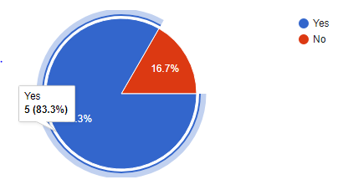

Figure 1. 1

According to the data collected from a random sample of students from the Jomo Kenyatta University of Agriculture and Technology who have interacted with the web based SODeL e-learning system 83% recommended that it to have a mobile application developed.

## **3.5 System Development Methodology**

### **3.5.1 The Unified Process**

The unified process is a use-case-driven, architecture-centric, iterative and incremental development process framework that leverages the Object Management Group's (OMG) UML and is compliant with the OMG's SPEM (Software Process Engineering Meta-model Specification)

The unified process is broadly applicable to different types of software systems, including small-scale and large-scale projects having various degrees of managerial and technical complexity, across different application domains and organizational cultures.

## **3.6 System specification**

System specification describes the features and behavior of a system or software application. It includes a variety of elements that attempts to define the intended functionality required by the customer to satisfy their different users. System specification also defines at a high-level the main business processes that will be supported, what simplifying assumptions have been made and what key performance parameters will need to be met by the system.

**Functional requirements**

The application is expected to do the following.

* Recognize and Authenticate users’ credentials.
* Manage and store users’ information.
* Manage and maintain course contents
* Display grades when needed by the student.

**Nonfunctional requirement**

The non -functional requirements are as follows:

**Maintainability**

The administrators should have the ease of maintaining the system by, correcting errors, preventing breakdown, perfecting the system and ensuring that it adapts to the changing needs of the user.

**Usability**

The system will be friendly to all users due to simple user interfaces and proper documentation of the system.

**3.7 System Design**

System design is the process of defining the architecture, components, modules, interfaces and data for a system to satisfy specified requirements. System design therefore is the process of defining and developing systems to satisfy specified requirements of the user.

#### **3.7.1. Logical Design**

What a system is doing will change less over time than how it is doing it. This is often conducted via modelling using use case diagrams, class diagrams, Entity- Relationship Diagram to show the flow of activities. In this way, we can furnish an abstraction of the total system through logical design in an orderly explanatory way.

#### **Use case diagram**

Use case diagrams give a graphic overview of the actors involved in a system together with their different and how these different functions are interacted

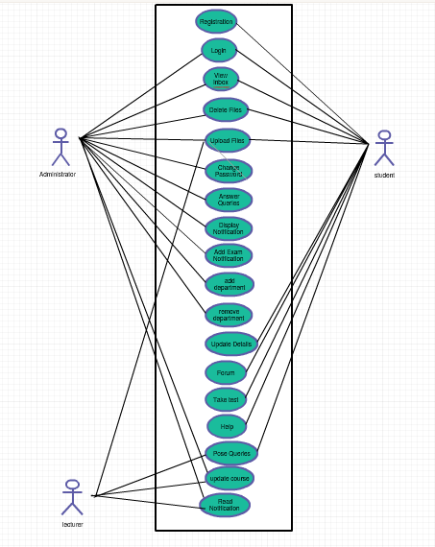

**Sequence Diagram**

Sequence diagram, shows how different stakeholders interact with a system by showing activities performed by different stakeholders.

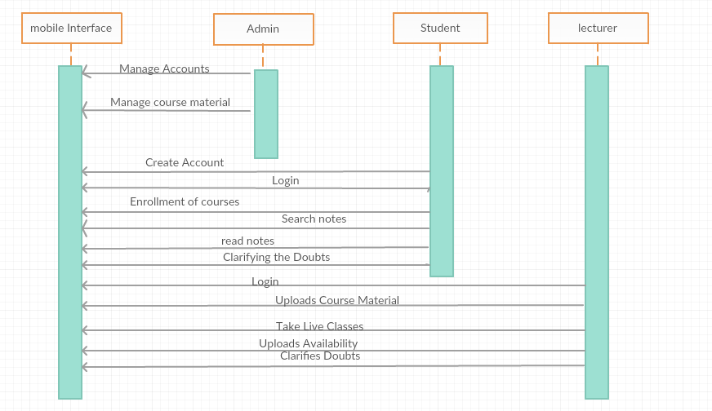

#### **3.7.2. Physical Design**

shows the actual input and output of the system

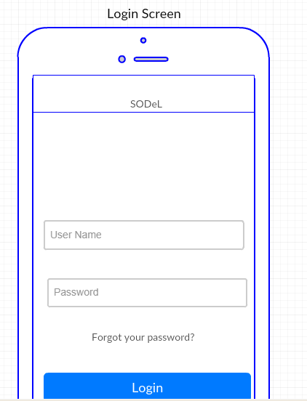

Showing the course units’ page

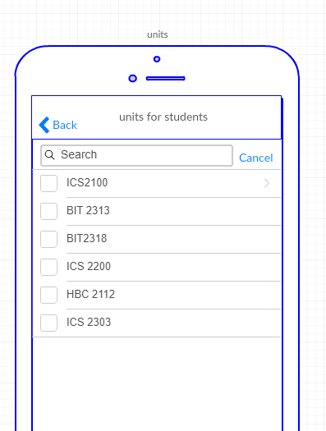

**Sample Questionnaire**

I'm James Njoroge Njuguna from Jomo Kenyatta University of Agriculture and Technology. If it's not too much trouble take a couple of minutes to express your conclusions on the underneath inquiries. Your answers are essential to the accomplishment of this examination. Please answer with 'YES or NO' where required. This is the poll is aimed at getting opinion on development of a mobile based interface for e-learning

1. What’s your gender? Male [ ] Female [ ]
2. Are you a student? YES [ ] NO [ ]
3. If yes, which mode of study do you use?

Full-Time/Regular Day [ ]

Evening [ ]

Weekend /Part-Time [ ]

Distance Learning [ ]

1. Are you a Jomo Kenyatta University of Agriculture and Technology student?

YES [ ] NO [ ]

1. Have you used the SODeL e-Learning system?

YES [ ] NO [ ]

1. Challenges faced when using the web based e-learning system?

|  |
| --- |
|  |
|  |

1. Do you find the system effective? YES [ ] NO [ ] NOT SURE [ ]

If NO, what recommendations would you give?

|  |
| --- |
|  |
|  |

1. would you recommend a mobile application for SODeL?

YES [ ] NO [ ] NOT SURE [ ]

Thank you for agreeing to take part in this survey. All of the answers you provide in this survey will be kept confidential. No identifying information will be provided to the public. The survey data will be reported in a summary fashion only and will not identify any individual person.